1st October 2019

Dear Parents and Carers,
Healthy Packed Lunch
During the meet the teacher event last week, I reminded parents of our school policy to provide children with a healthy packed lunch.
Please find below a copy of the slide for your information.
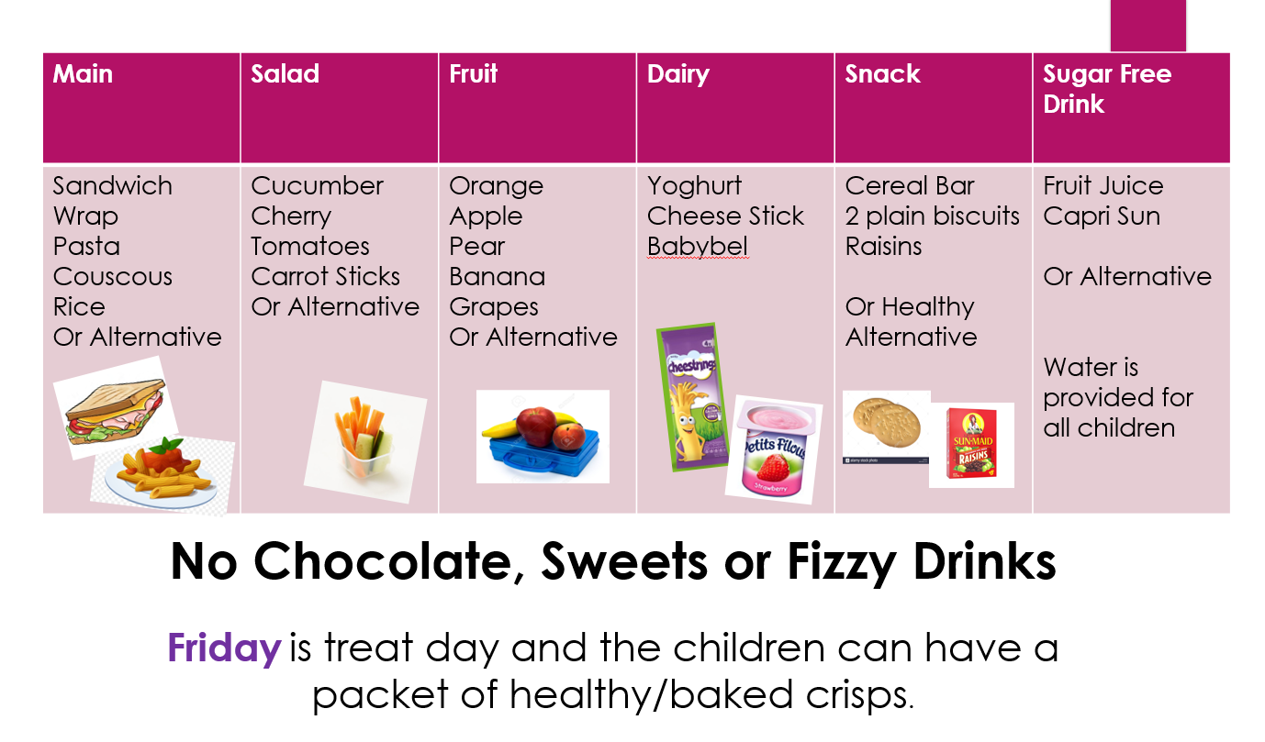
Kind regards,
Charlotte Angeli,
Headteacher

